In this lesson we will be quickly looking at Project settings in Natron
and how to export images and video in audio format
So in the last lesson we animated the rectangle
WE can export just a simple image here It dors not have to be a video
Set the frame range such that it counts all the frames containing our video such that the last frame in range is the last frame of the video
To save our project Go to file menu
nd then in submenu
click on File menu

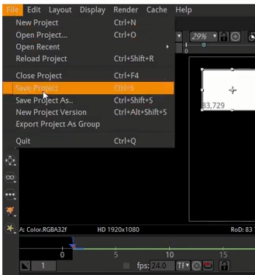
and then go to Save Project option

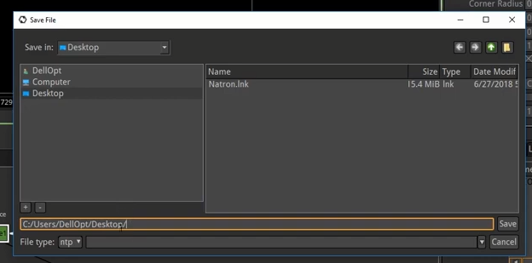
Now browse the area where you want to save your project
Now once the file is saved and it is created but the problrm with this is that e cannot email it and show it to other people unless they want to import it into natron and watch it on their viewer
You cannot upload your natron file to youtube or like we want to create a video out of this animation
To do that we create a write node
Now everything in our viewer is being piped up into the viewer we need to pipe it into the write node(who knows)

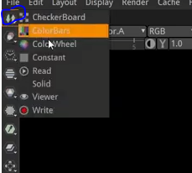
Now go to the marked area above and then in submenu click on the write option
Now a browse window will be opened

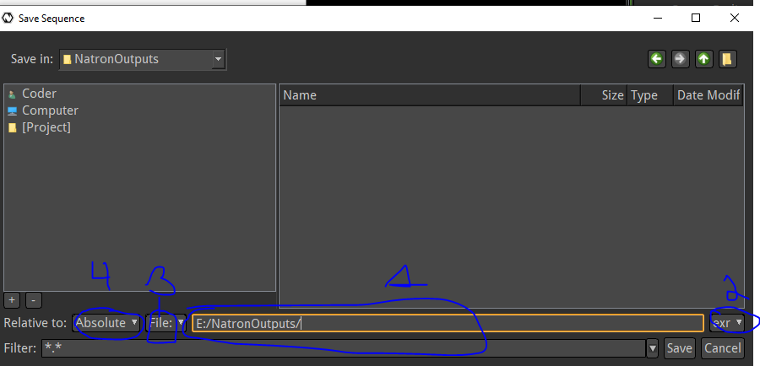
You can browse here where you want to export your output and in marked 1 you type the name of the file and then if you type the extension after it then the marked 1 will be automatically choosed
IN marked 2 you tell the type of file your want to export
If you tell the type jpg then it will show jpg if you type .mov then it will be changed to mov
Make sure you have correct file type for your thing

In marked 3 you choose whether you want to choose the sequence of file if you choose file then a file will be output but if you choose sequence then pictures will be outputted representing a frame
but we want only a video file so we choose file
So teacher is saying make sure you have chosen absolute in marked 4 and in marked 3 chosen File and then in marked 2 mp4 is chosen it is better to add extension in naming of your file in marked 1
Below marked 1 you can filter things in the folder you are currently in browse window
Now click on Save button

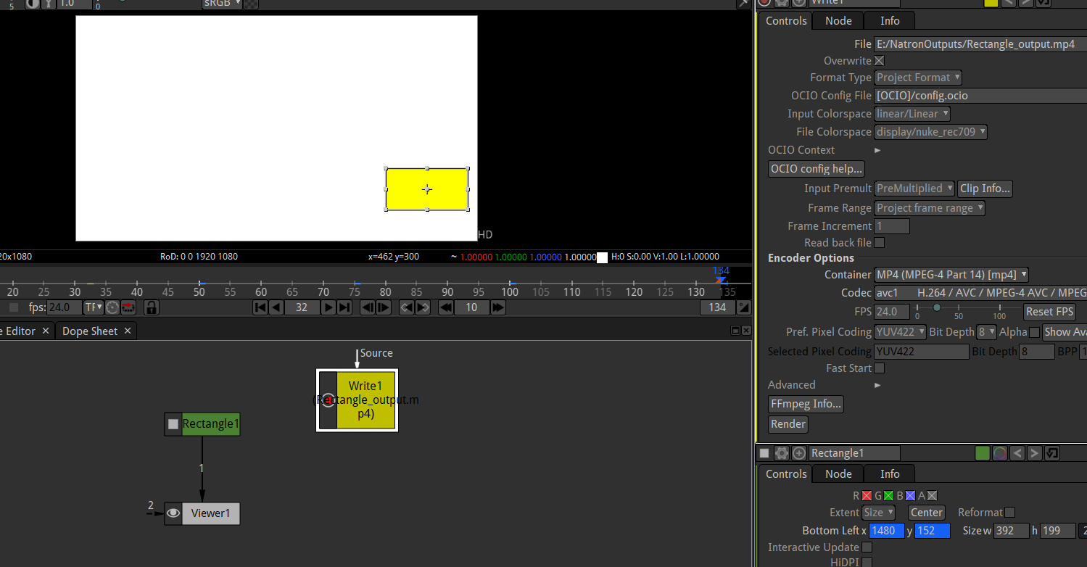
Now you can see the yellow colored node above in the node graph
Now if you select the writer node and then in properties window and then click on render to export as marked below
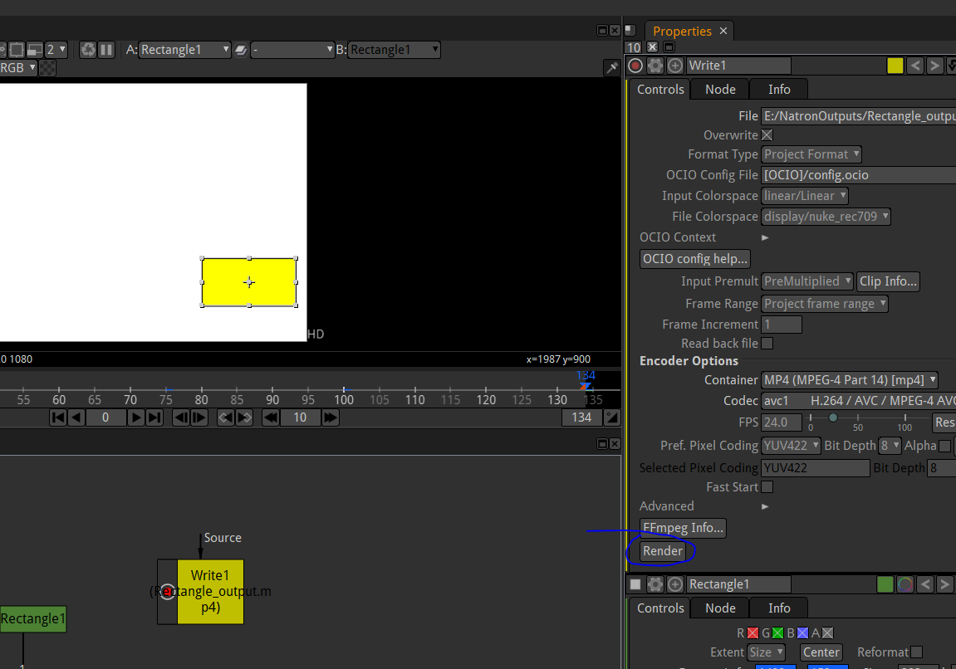
Now the error will be shown in exporting it and the error will be shown in red ribbon and in the new tab named as Progress opened along side with node graph tab as shown below

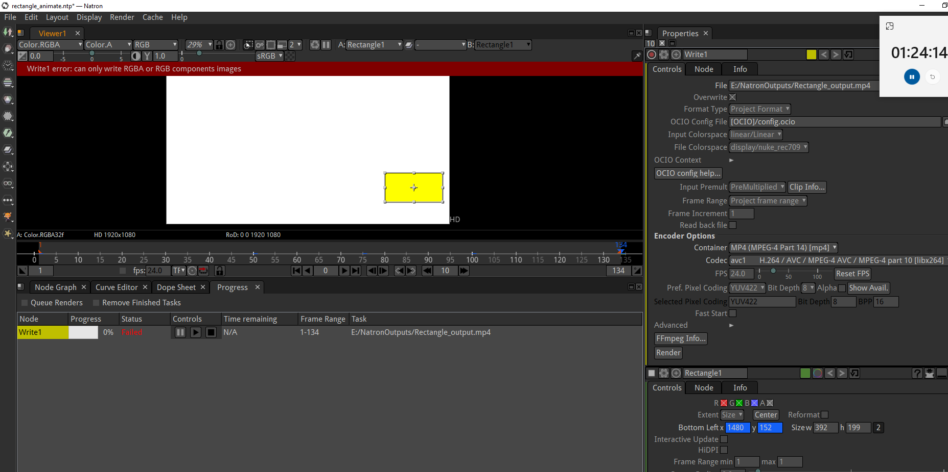
The reasonis that in our write node there is nothing to render there is nothing connecting to it

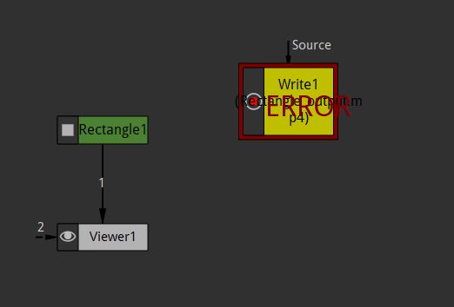
So what you need to is connect the rectangle to the write node since the rectangle node is the content we have worked on as shown below
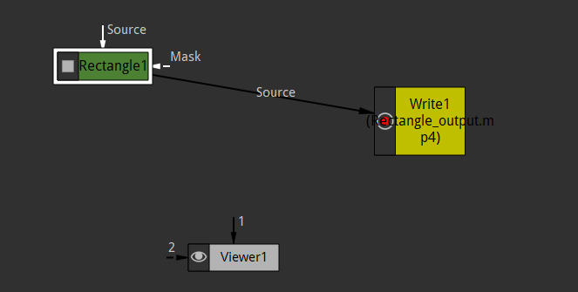
Now in Viewer window no video will be shown don't worry instead of showing it to the Viewer we are showing to the writer

Note:-

I think there are two type of nodes
First is source(content or data) and second is Destination (wjhere the content or data will go)
Now again we clik on the render button then this will render our animation to the destination we mentioned in our browse window
and you can see the progress in progress tab

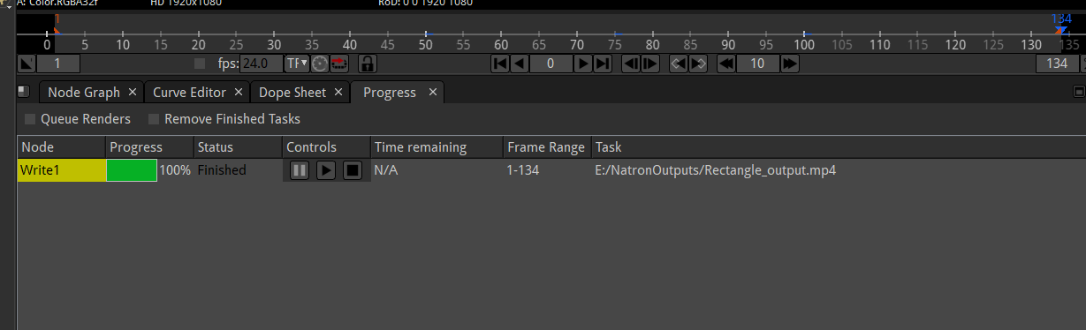
you can reconfigure your write node
By going to properties window you can click on the marked below

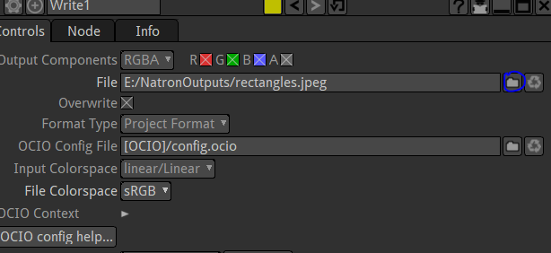
to open teh browse window

Lets go over some of theoption we have in properties of write node
you can move one tab from one window to another window by dragging the tab to tab section of anpther window

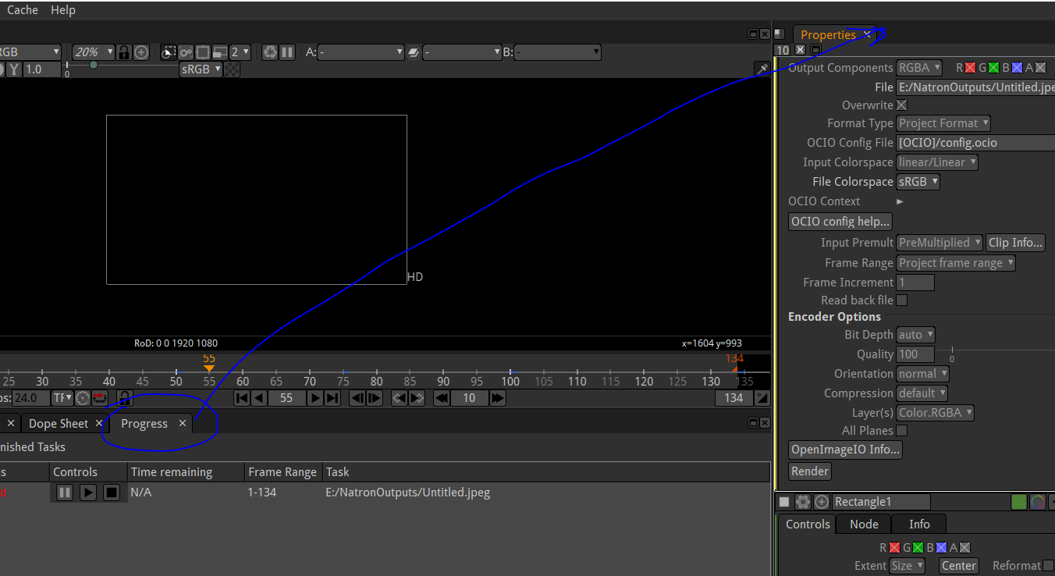
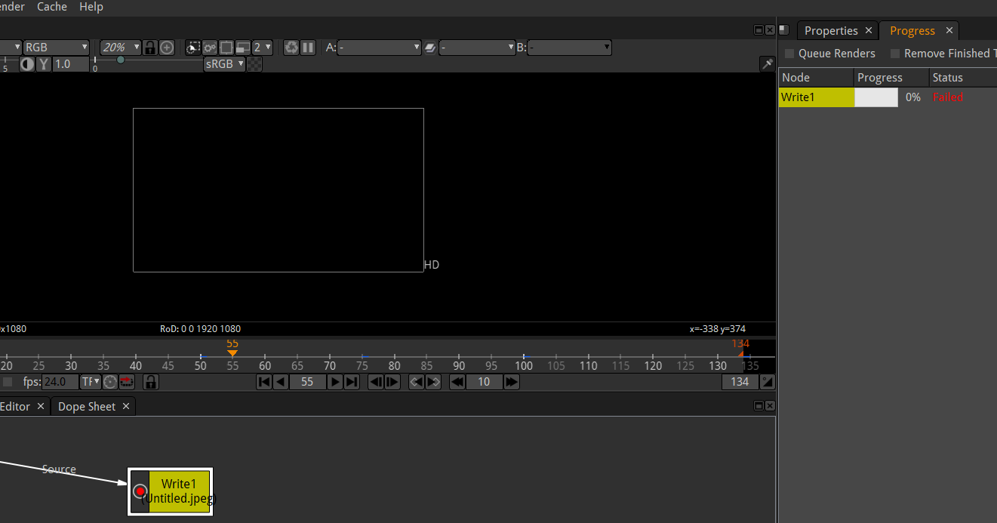

You can render specific frame in the video and tri that part of the video
by going to propertires window of the writer node
and then you can go to Frame Range as amrked below

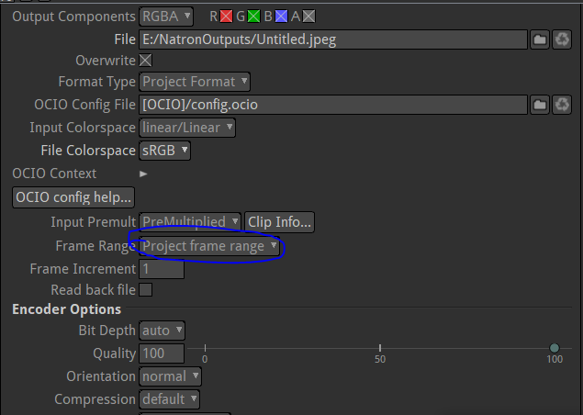
Since the Frame range is set to Project frame range dso it will be by default take all the frame of the video
If you choose manual then ou can set the range by first frame and last frame

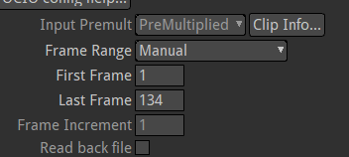
if you increase the frame rate then the speed of video will increase aand the video become more smooth
To set the frame rate of your output then go to writer noed properties and then edit the fps as marked below
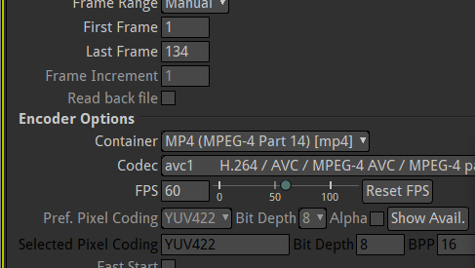
Note:-
I think the project setting represtns the viewer node
I think that one node should be compatible with the other node it is supposed to be connected with
I think you can connect one node to multiple node

We can connect Rectangle node to Viewer node and writer node as well due to which you can also view your content in preview window and and also make its output wioth the help of writer node so in this case we first connect rectangle node to Viewer node and then wroiter node to Rectangle node
as shown below

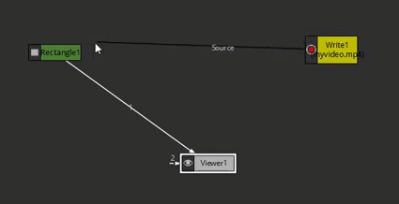

No it will look like below
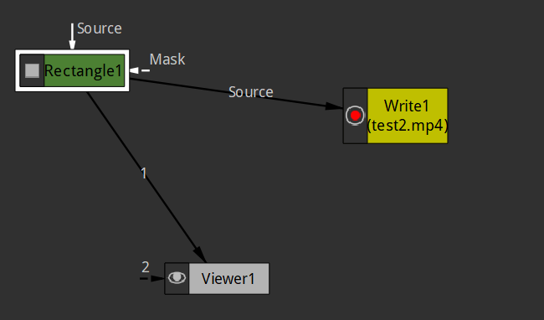
Now i think that Rectangle is the source node do it is pointing to both the viewer node and writer node as well

7:30

if we want to see what is the information of the video playing in vlc
So first go to tools menu and then to media information

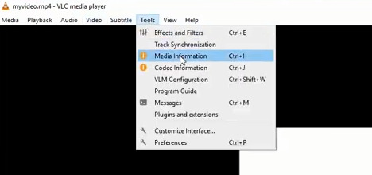
and now new window will be opened
Now go to Codec tab and now its information will be shown here

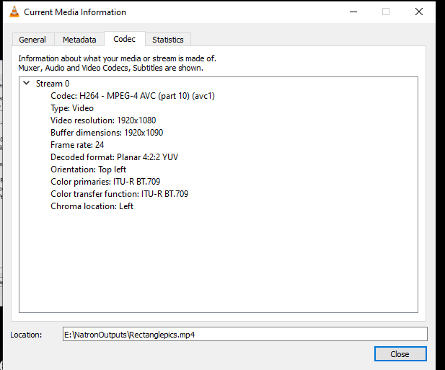
When you start importing clips to work then they are going top have their own frames and they have been shot in 30 fps so you can adjust fps in Natron
Now play with different option we have on the write node if there is anything you want to look at
We can export a single image as an output by typing .jpeg or any image extension in the file filee field pf write browse and then in the propertie of writes set the first and last range equal to a frame whose image you want to export.

So this time an animation will not be exported but a single image file nd not an animation

